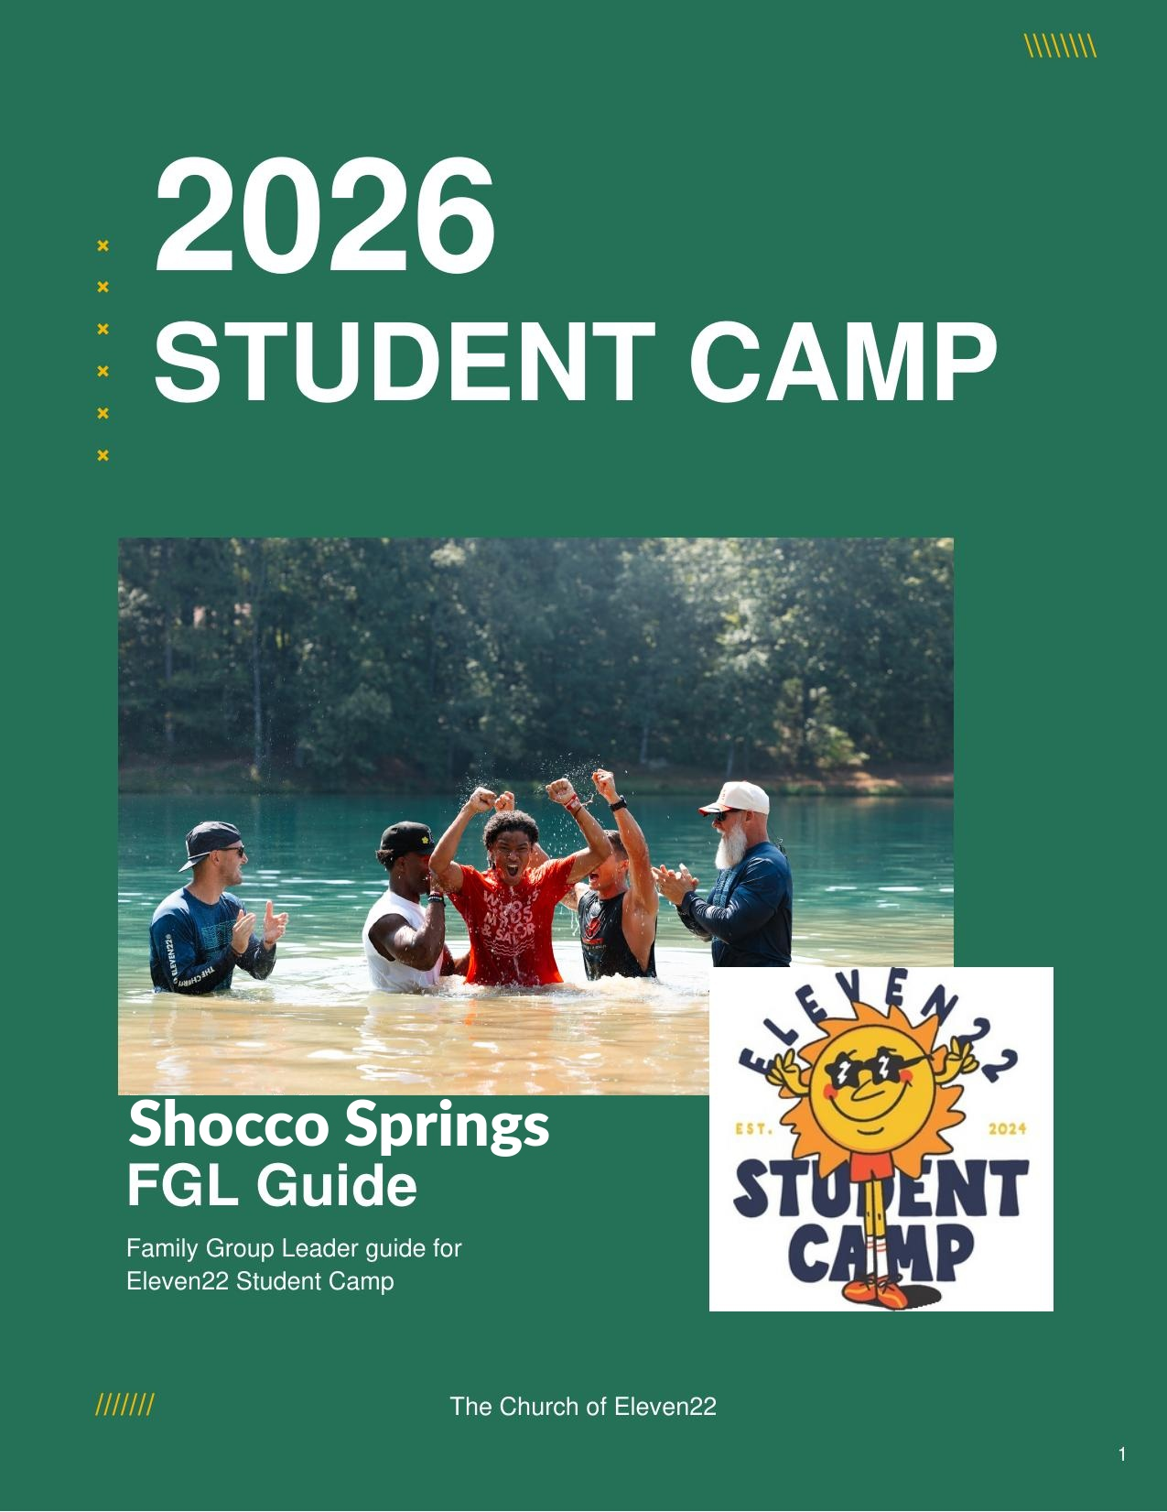

FAMILY GROUP LEADERS – SHOCCO SPRINGS
8th Grade: July 23-27th
High School: July 27th-31st

THANK YOU for serving as a FGL! You play a crucial role during camp to help students discover and deepen their relationship with Jesus. We are grateful for your willingness to sacrifice time from family and work to make an eternal impact on students’ lives. You are the backbone of camp!
THEME OVERVIEW
◆ FIRST AND BEST
- This year’s theme is First and Best. God is first. He’s not just first on a list of priorities, but the page every priority is written on. And because He is first, He went first. He gave His first and best through Jesus while we were a broken mess.
- Our hope is that every student leaves Student Camp having wrestled with one question:
  - “What or who is actually first in my life?”
- As they worship, dig into the Scriptures, and unpack next steps in Family Groups, we pray they encounter Jesus and respond to Him with their First and Best in every area of their lives.
◆ Content Overview
- Road to Camp: Get to know your students at the lunch stop
- Session 1: God is first. It’s who He is and where He is. Because God is first, we respond with our best. Col 1:15-20
- Session 2: Identify and surrender idols in your life so that you can give God your first and best. Col 1:18-20 & 1 Samuel 5:1-5
- Session 3: Identity precedes activity. Who we are in Christ shapes our next steps. Col 1:20-22
- Session 4: As we follow Jesus, we take next steps of obedience daily. Colossians 1:23 & Ephesians 2:8-10
FAMILY GROUP LEADER EXPECTATIONS
◆ FGL Responsibilities
To make the most out of leading and investing in your Family Group, below are a few critical responsibilities:

- BE PREPARED: By June 20th, watch the training videos. Be familiar with the content, listen and take notes during sermons, and be ready to shepherd your students while at camp.
- FACILITATE A DAILY BIBLE STUDY: Don’t freak out. We will provide a leader guide and train you daily. All you need to do is lead a conversation around Scripture and the session sermons.
- ATTEND THE DAILY FAMILY GROUP LEADER MEETING: Join us as we walk through the day’s Bible study. We’ll provide coffee and details for the day, so you’re fully prepared!
- PRAY WITH AND FOR YOUR STUDENTS: Pray for students before and during camp, as well as modeling prayer during Family Group can supernaturally open eyes and hearts.
- KNOW YOUR STUDENTS: Capitalize on all the time you will have with students this week. Eat meals with them, do free time options, walk to services with them and complete 1:1’s with every student. You have 5 days to invest in your students, don’t waste a moment!
◆ CAMP CULTURE & ValueS
Camp has the potential to be a transformational experience in the lives of our students and many will surrender to Christ for the first time. With this being the second year of Eleven22 doing our own camp, you have a critical part of building a healthy camp culture. Culture is the way we do things and why. Why we do something is way more important than what we do. As FGL’s you carry the culture at every bible study, worship session, and lunch table. These are values that will help you lead well:

- REMEMBER THE WHY | We are here to help students discover and deepen their relationship with Christ. Everything we do: the bus ride, hallway conversations, rivalry, worship, and all the craziness of camp is to point students to Jesus Christ. We are not at camp to win a rivalry game, a dodgeball tournament, or just to have fun. Everything we do is done with purpose of pointing students to Christ.
- DON’T WASTE LUNCH | Every moment matters. During camp we want to maximize every minute. We maximize every moment to build meaningful relationships with students. We sit with students at lunch, worship, and are all in every activity. Why? To build relationships to leverage for the Gospel.
- BE THE THERMOSTAT | You set the energy, tempo and vibe of your family group. Be all in. If your group is tired, get amped up for the rivalry game. If your students are all over the place during Bible study refocus on them what matters. Engage in worship. Take notes during the sermon. Model for your students what a disciple looks like. Bring the spiritual intensity in everything you do.

- BE AN OWNER | Camp takes an army of people to be a success. The only way this happens is if every adult serving takes ownership over their area and is proactive in solving problems. You are not just a participant at camp, you are an owner. Be at places on time, clean up spaces, move chairs, solve problems and be proactive.

As a Family Group Leader we wanted to paint a picture of what a win looks like. If you model the above four values, we believe you will maximize your impact at camp. Also, when you see a fellow FGL modeling these, tell them, encourage them, and celebrate them leading well! We can’t wait to see what God does in you and through you at student camp this year!
SHEPHERDING STUDENTS
- Care Team — At camp, we recognize there might be challenging circumstances that come up. This could be a student walking through self-harm, difficult interpersonal relationships, or even discipline issues. We have a team that will help the student ministry shepherd these students. FGL’s go to your student minister first with any care concerns. Then student ministers need to pass onto care lead and camp director.
- Mandatory Reporting — YOU are mandatory reporters. Please review the mandatory reporting training in the video training. You can go to your student minister if you have questions while at camp.
  - Being a Mandatory Reporter means that if a minor (under 18 years old) student reports physical, emotional, sexual, or verbal abuse of any kind, we need to report it. All of us. Every pastor, minister, intern, serve staff, counselor, nurse, etc.
  - Examples of other things to report to Student Minister:
    - Imminent risk of self-harm
    - Imminent risk of being harmed by others
    - Imminent risk of harm to others
- Phone Policy — We want to limit distractions, so students can turn down the volume of the world and turn up the voice of God. During worship and FG sessions we will ask students to put their phones away.
- Meds Procedures — Students will be turning in meds at check in. At both Shocco and Yale there will be med stations.
IMPORTANT DETAILS: SHOCCO SPRINGS
◆ Arrival Times
- Serve Staff arrives for check-in process at 5:15 am. Huddle begins at 5:30 am.
- Serve staff to drop luggage off in parking lot prior to entering San Pablo/St. Johns
- Check in at San Pablo: SP, PV, BAY, ARL, NJX, & WLD

- Check in at Saint Johns: STJ, OP, FLM, MAN, PAL, OCP, STA
  - *Jesup separate check in
- They will be given a luggage tag in the parking lot
- You will then go to SP or STJ for check-in (Background check, family group # and training videos)

◆ Daily Rhythms at Student Camp:
- Morning worship and main session
- Family Group time (Bible study & discussion) with students of the same grade and gender
- The Rivalry and free time in the afternoon
- Evening worship and campus gatherings
- Late Night themed experiences before lights out

◆ Schedule for Shocco Springs:
Day 1
6:30am - 8:00am Check-in at San Pablo / St Johns Campus
8:30am Depart San Pablo / St Johns campus for Shocco Springs
4:00pm CST Arrive at Shocco Springs (Time change to CST)
5:15pm Dinner
6:45pm Family Groups
8:00pm Main session
10:00pm Campus Groups
11:30pm Lights out / Quiet Hours

Days 2-4
6:45am Breakfast begins
8:15am Campus devo
9:00am Morning Show and main session
10:30am Family Groups / The Rivalry
11:45am Lunch
1:15pm Family Groups / The Rivalry
2:45pm Free Time
5:00pm Dinner
6:30pm Family Group prayer gathering
7:00pm Main session
9:00pm Campus Groups
10:15pm Late Night activities
11:30pm Lights out / Quiet hours

Day 5
6:45am Breakfast begins

8:45am Depart Shocco Springs for San Pablo / St Johns campus
6:30pm Arrive at The Church of Eleven22, SP/STJ

◆ Late Night Activities for Shocco Springs
- USA 250 Party 🇺🇸 - Hear ye, hear ye! Celebrate 250 years of the USA at camp’s biggest patriotic party. Dress in your best red, white, and blue and prepare for USA fun and to head to the pool for the legendary USA 250 Bellyflop Contest. (meeting location Pool Deck)
- Glow With the Flow 🎧 - Grab your neon and windbreakers because camp is going full 80s! Dress in your best retro outfit and hit the silent disco for a night of throwback hits, nonstop dancing, and glowing energy. Pick your channel, grab your friends, and light up the dance floor.
- Talladega Nights 🏁 - Start your engines and get ready for a high octane night at camp! Dress in your best NASCAR and camo/redneck gear as the party comes alive! You will enjoy a night of fun and fellowship! Then it all comes down to the grand finale, the Talladega 500, where everyone gathers to watch the ultimate race and see who takes the checkered flag (meeting location MES)
◆ Rivalry
  - Vikings (Purple) (ARL, BAY, NJAX, OP, STJ, WLD, MAN, PAL) — Girls
  - Special Ops (Green/Camo) (FLM, JSP, PV, SP, STA) — Girls
  - Raiders (Black) (ARL, BAY, NJAX, OP, STJ, WLD, MAN, PAL) — Boys
  - Gladiators (Red) (FLM, JSP, PV, SP, STA) — Boys
◆ Packing List
Here’s everything your student needs to pack for camp:

- Bible and pen
- Bedding and pillow (sheets, blanket and pillow)
- Modest clothing for four days, including athletic clothing
- Modest swimwear
- Dark-colored shirt for water day at The Rivalry
- Clothing that reflects your rivalry squad
- Tennis shoes and sandals
- Refillable water bottle
- Hat
- Towel/washcloth
- Beach towel
- Toiletries
- Trash bag (for wet clothes)
- Prescription and daily medications (prescription medications to be turned in at check-in)
- Sunscreen
- Bug spray
- One carry-on bag for the bus and one large bag/suitcase to be stored under the bus

PRAY
- Pray students would surrender their lives to Jesus and that the Gospel would change everything about everything in their lives.
- God is first. Pray students would surrender to that reality. Ask God to reveal anything competing for their worship and that students would respond by giving him their first and best.
- Pray students would return home bold in their faith and ready to impact their homes, schools, teams, and neighborhoods by reaching one more.

